**Arrays and For Each Loops**

**Objective:** We're starting the process of only shooting when the button is pressed. We're going to be covering the concepts of Array's and also the concept of for each loop.

Arrays

**What is an Array?**

Array allows us to store multiple objects in one variable

We can only store the same Type of objects in the array variable

If a variable is a box that can hold data. An array is a box holding boxes.



**Kairi**

**Ori**

**Cow**

**Leon**

[0] [1] [2] [3]

names

string[] names = {“Leon”, “Cow”, “Ori”, “Kairi”}

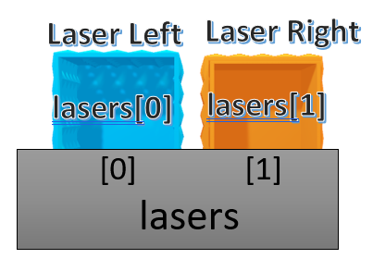

One of the tools will be using in this lecture is the ability to activate and deactivate a game object. First lets rename the **Bullets** to **Laser Left** and **Laser Right** in our Hierarchy.

|  |  |
| --- | --- |
| **Active** |  |
| **Deactivated** |  |

The SpaceShip has two Laser Bullet GameObjects

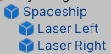

1. Open **PlayerController.cs**. Under **yRange** variable (line 12) lets create another [SerializeField] variable. Its going to be an array of GameObjects called lasers.



1. Go to Unity to check that it worked and you should see

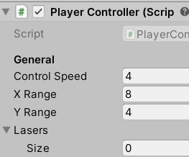

Its of size zero because we haven’t stored anything yet.

1. While having the **PlayerShip** selected lets **lock the inspector** so it doesn’t move from the SpaceShip values.

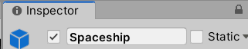

1. Select both **Laser Left** **and Laser Right** (use SHIFT or CTRL) and drag them to the Lasers [SerializeField] on your SpaceShip.

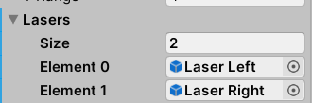

1. Unlock your Inspector
2. Find your **ProcessFiring** method in your **PlayerController**
3. Instead of logging shooting and not shooting lets create two new default methods called **ActivateLasers and DeactivateLasers**

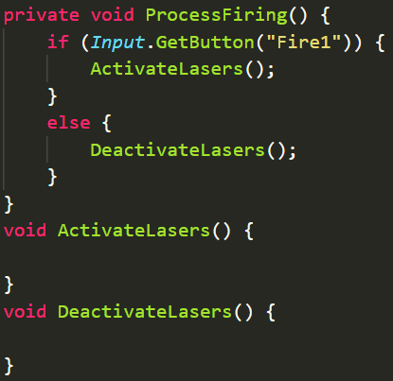

1. Inside of ActivateLasers lets put some pseudocode

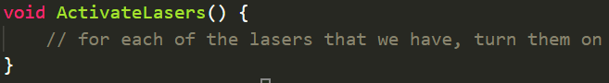

What is a For Each loop? it’s a control flow statement for traversing a collection

1. Lets create one inside of **ActivateLasers**. So for every laser in the lasers array lets…… 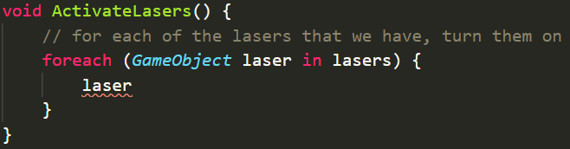Do you guys remember what we need to do to activate a GameObject (hint we did it with the particle explosion a few lessons ago)
2. If you remembered or went back to your code to look it should have been this

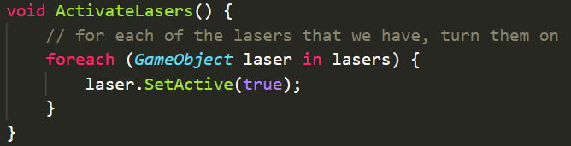

1. Deactivate lasers should look like this

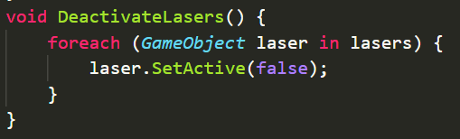

1. Go to Unity and test your changes.

Now this code isn’t perfect, but we’ll refactor it later. Also you might have noticed that when we stop shooting not only do we stop producing new lasers but the ones that are flying through space also disappear. We’ll fix that later too.